July 24, 2019

Dear TC3 Grantee Teams,

Please find the attached site visit sample materials to use for your upcoming site visits. You may choose to customize any of these tools for your initial site visit. Or, you may use these tools as is for your first site visit, then customize based on learnings for your subsequent visits.

We recommend printing one of these packets for each person who is participating in your site visit observations and debrief. If you would like CCI to print packets for your initial site visit that CCI staff will be attending, please let Alexis know and provide the number of packets you will need.

Attached:
- Example Site Visit Agenda and Contact/Participant List (RUHS)
- Site Visit Observation Tool
- Sample Debrief Agenda
- Process Flow Map Worksheet
- Sample Observation Debrief Notes Template

For questions or support in tailoring these tools, please contact your coach, Denise Armstorff, and TC3 Program Manager, Alexis Wielunski.

Kind regards,
The TC3 Team at CCI

TC3 GEMBA AGENDA
Healthy Hearts, Healthy Home

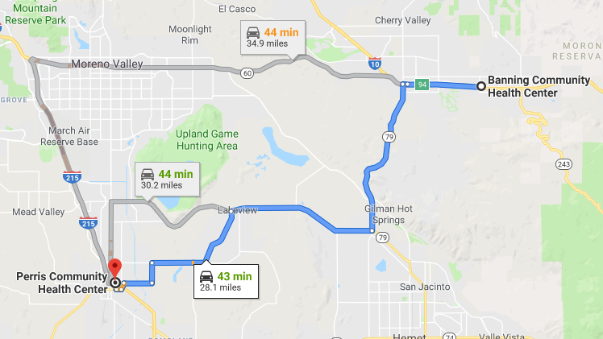
GEMBA Site information

Banning Community Health Center
3055 W. Ramsey, Banning, CA 92220
951-849-6794

Perris Community Health Center
Dr. Robert Bruce Reid Health Center
308 E. San Jacinto Ave., Perris, CA 92570
951-940-6700

Time | Location | Activity
Banning Community Health Center
7:30 AM | Nurse station | - Observe morning huddle
8:00 AM | Conference Room | - Gather to organize and review data collection materials and receive observation assignments
8:30 AM | Various areas | - Observation of process and activities with care teams
10:30 AM | Nurse station | - Wrap Up & Thank You
11:00 AM |  | - Transition to Perris Community Health Center
Perris Community Health Center
11:45 AM | Front Conference Room (TBD) | - Regroup for lunch  - Banning Debrief  - Perris Welcome  - Gather to organize and review data collection materials and receive observation assignments
1:30 PM | Nurse Station | - Observation of process and activities with care teams
3:00 PM | Front Conference Room (TBD) | - Gather to debrief learnings and discuss next steps

RUHS Contact/Participant List

In attendance? | Name | Role | Contact information
 | Edward Bacho | Physician In Charge – Banning, Associate Med Director
 | Kimberly Bowker | Director of Operations
 | Kristin Delgado | Site Manager - Perris
 | Barbara Ganchingco | Physician in Charge – Perris
 | Fang-Tzu Hamade | Senior Clinical Pharmacist
 | Shelly Hannah | Site Manager - Perris
 | Mahbuba Khan | Associate Med Director – East
 | Peter Lee | Associate Med Director – West
 | Geoffrey Leung | Medical Director
 | Sherry Marston | Nurse Coordinator – Perris and Banning
 | Jonelle Morris | Executive Director – Ambulatory Care
 | Kirsten O’Dell | Nurse Coordinator - PRIME
 | Diep Tran | Administrative Services Officer
 | Shunling Tsang | Associate Med Director - Quality

Site Visit Observation Tool
Use this template to capture your observations during the site visit. This can help you draw a high-level process flow map.

Start Time/  End Time | Step Name | Role Responsible | Observations (happy moments for patients/staff, pain points, confusion, delay, missing inventory, process failure, etc.)

Sample Debrief Agenda
TC3 Grantee Site Visit

Agenda Item | Notes | Suggested Time | Supplies Needed
For each process observed, create high-level process flow map(s) of what you saw | - If different people shadowed different processes, break into small groups to create different process flow maps  - You can use your observation log to help  - Take pictures & make sure you document the process flow map(s) | 15 minutes | Process Flow Map Worksheet  Stickies & Sharpies  Camera
Collectively fill out the TC3 Site Visit Observation Debrief Notes | - For each process step/focus area, discuss your assumptions and observations, and identify potential areas of opportunity.  - Depending on the size of the group, you could break into smaller groups, complete different sections, and then come back together to discuss. If you use this approach, it may be helpful for each group to take notes into a google doc or other collaborative tool. | 60 minutes | TC3 Site Visit Observation Debrief Notes Template  Computer for note taking
Debrief and Next Steps | - Which site(s) are we visiting next?  - What did we learn today that will help inform our future site visits?  - Consider what worked well today and what didn’t. What do we want to adopt/adapt/abandon for future site visits? Consider doing a silent brainstorm on stickies then sharing what you wrote with each other. | 15 minutes | Computer for note taking  Stickies & Sharpies

Process Flow Map Worksheet
TC3 Grantee Site Visit

Site Visit Team Member(s): _____________________________________________________________________ Date: _____________________________________

Site/Unit Observed: __________________________________________

Process Observed | Who Was Involved, and What Was Their Role? | Tools & Technology Used
Use the space below to draw a high-level process flow map for the process you observed with 4-5 high level steps

Sample Observation Debrief Notes Template
TC3 Grantee Site Visit
Site Visit Team Member(s): _____________________________________________________________________ Date: ______________________________________

Site/Unit Being Observed: _______________________________________________ Process(s) Being Observed:______________________________________________

Process Step/ Focus Area | Assumptions  - What questions do I have regarding the current state process?  - What do I want to learn about?  - What am I looking for? | Observations  - What is being done  - Who is doing it?  - When are they doing it?  - How are they doing it?  - What is the patient-family experience like? | Opportunities  - What ideas for improvement did you note?  - What might be done differently to improve the process?  - Does physical environment contribute to efficiency of task(s) (e.g., do staff have to move from place-to-place to gather materials/equipment, usher patients, use EHR)  - Are there delays or wait-times? How might delays/wait-times be used to add patient value?  - Are there tasks/activities that seem unnecessary (busy work or overwork)?  - Were “breaks” or “gaps” in the process observed?  - Was there evidence of a work-around or short-cut? If so, is there evidence as to why/how the need arose to use the short-cut or work-around?
Registration/Pre-visit | - Are patients who already have diagnosis of hypertension identified prior to the visit?  - Is there communication between registration rep./MA (warm hand-off)?  - Are any visit preparation materials provided to patient (e.g., agenda/goal setting, information to support self-management)?
MA conducting intake/rooming | - At what point in the visit is BP measured?  - Where in the clinic is the patient’s BP measured?  - What technique is used to take BP?  - What actions does the MA take when the BP measure results are abnormal?  - Is any hypertension education provided by the MA to the patient?  - Is there a warm hand-off from MA to provider regarding abnormal BP reading?
During the Visit | - Is there any discussion regarding patient self-management support?  - Is patient given an opportunity to discuss his/her agenda and/or goals?  - Does the patient seem to be clear on information and/or instruction(s) provided?  - Do staff/providers solicit demonstration of patient’s understanding of shared information/instructions?  - At what point in the visit are medications reconciled and who discusses this with the patient?  - Who manages refill requests?
Hypertension plans for post-visit | - Are follow-up instructions provided and communicated to the patient? If so, what are the instructions, who communicates them, and how are they communicated?  - Is there evidence of processes that will support patient self-management/adherence (e.g., motivational interviewing, f/up phone calls, case management)?
Reference Tools/Helps | - Do the clinic staff/providers demonstrate use of any BP reference tools regarding protocols or workflows during the visit?  - Does the EHR provide shortcut/smart phrases for clinicians/staff use to record BP? Are they using them?
Team-based Care | - Is there evidence of team-based care (e.g., co-location of staff/providers, huddles, pre-visit planning)?  - Is there evidence that hypertension control is a practice priority?  - Do the staff demonstrate understanding and focus on patient-family engagement?
Use of Data/Information Systems | - How are data and information systems supporting documentation of BP?  - How is data used/recorded?  - Are there alerts, alarms, or other signals?

