How to use the VR Headset / Steps 1 – 4

1) Check the equipment | 2) Choose an experience
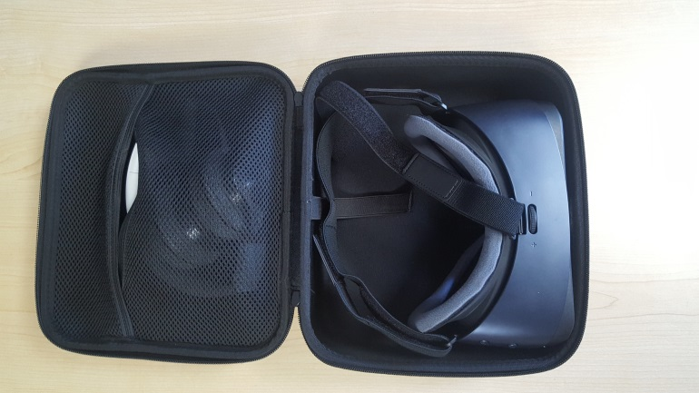 | 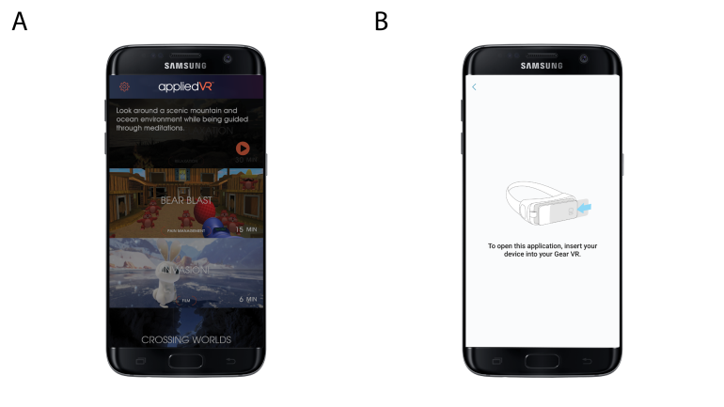
Each kit includes the following: Samsung GearVR headset w/ velcro straps, Samsung Galaxy S7 Smartphone, USB Micro charging cable, USB-C charging cable, disposable/reusable liners. | A) Select an experience from the menu and press the orange play button.  B) Make sure you see the start screen that says, “please insert your device into your GearVR.”
3) Open the clips | 4) Insert the device
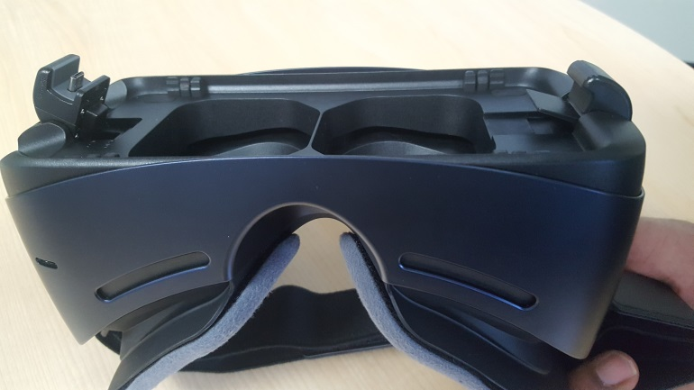 | 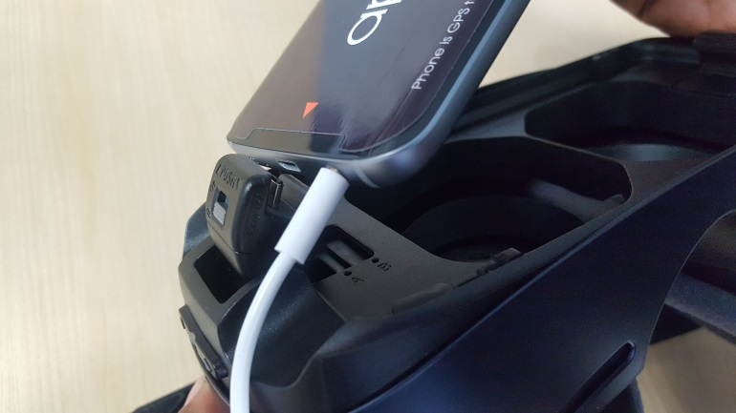
Open the two clips before inserting the phone. The USB clip has two positions, A and B. Make sure it is locked in position B.  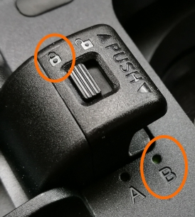 | Plug in the headphones to the auxiliary port, before inserting the phone into the headset. Push firmly to make a tight connection between the USB plug on the headset and the USB port on the phone. Then, snap the phone into place using the clips.

How to use the VR Headset / Steps 5 - 8

5) Apply bouffant cap | 6) Apply disposable liners
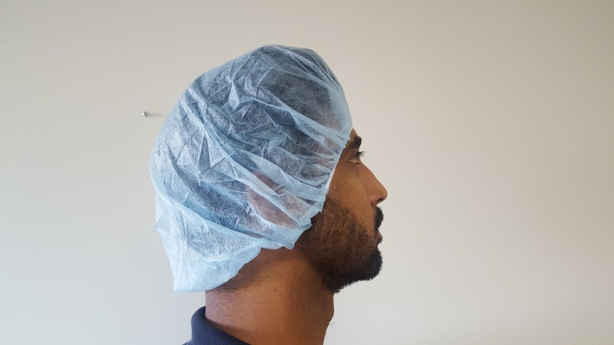 | 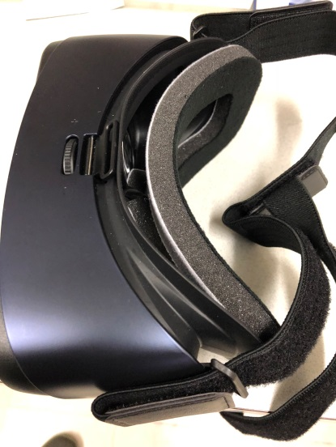
Fit the bouffant cap so that it is covering the patient’s hair. | Fit the Velcro disposable liner to the VR headset
7) Patient begins experience | 8) Patient adjusts settings/controls in VR
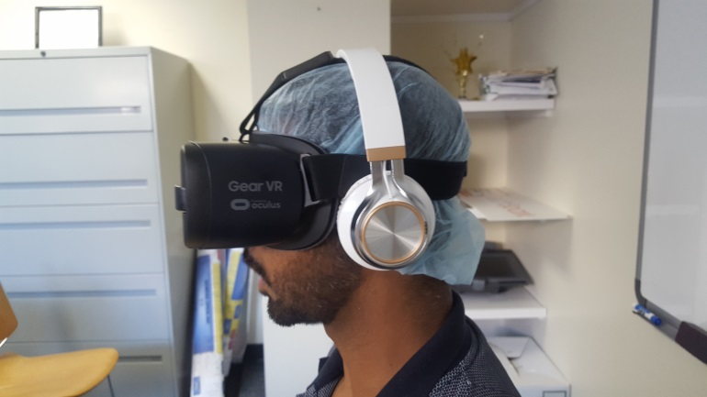 | 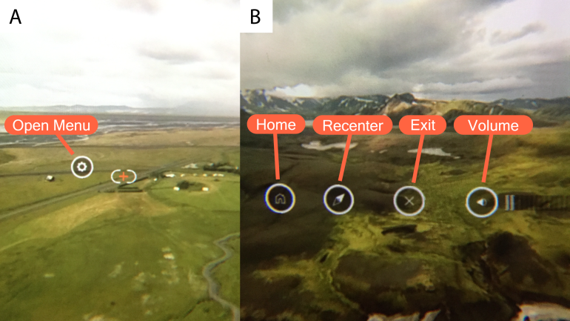
Help the patient put on the VR headset by adjusting the straps and handing them the headphones. After they put on the headset, the experience will automatically begin. | A) Open the VR menu by holding your gaze at the gear icon.  B) Use the controls on the menu to select a new experience, recenter the visuals, exit the menu, or adjust the volume.

