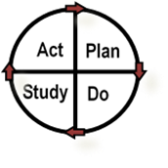
Date:
Name of Test:

Describe briefly, at a high-level, the test of change you are planning (What is the objective? What questions do we want answered with this test?):
PLAN
What is your plan? (Answers who, what, when, and where):
List the tasks needed to set up this test of change | Person responsible | When/where will it be done?
Predict what you believe will happen when the test is carried out
What data will be collected to determine if your test is successful?
DO
Describe what happened when you ran the test (what did you observe?)
STUDY
Describe the measured results and how they compared to the predictions (what did you learn?)
ACT
Describe what modifications will be made to the plan for the next cycle (based on your learnings)

