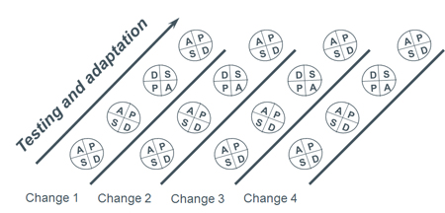
PDSA Tracker Worksheet: Use with each change you are testing

Title of PDSA: | Aim statement:

 | PLAN |  |  |  | DO |  | STUDY | ACT
PDSA Cycle No. | What change are you testing? | What have you learned from previous PDSAs? | What do you predict will happen? | What data will you collect to know how it’s working? | Date(s) of test | What did you do? | What did you learn? | What will you do next? (ex. forget it, more testing, ready to implement, ready to teach others)
1
2
3

