SUDCM PACKET

.SA11MATSUDCM

Click on any of the following:
- Intake
- 1x1
- BUP Bridge
- BUP Refill
- MAT Group
- Case Management (Non – MAT patient)
- CCN (Case Conference Note)
- CC (Care Coordination for all non-face to face encounters)
- Contingency Management
- Phone
- ER Referral
- Jail Referral
- Program Discharge

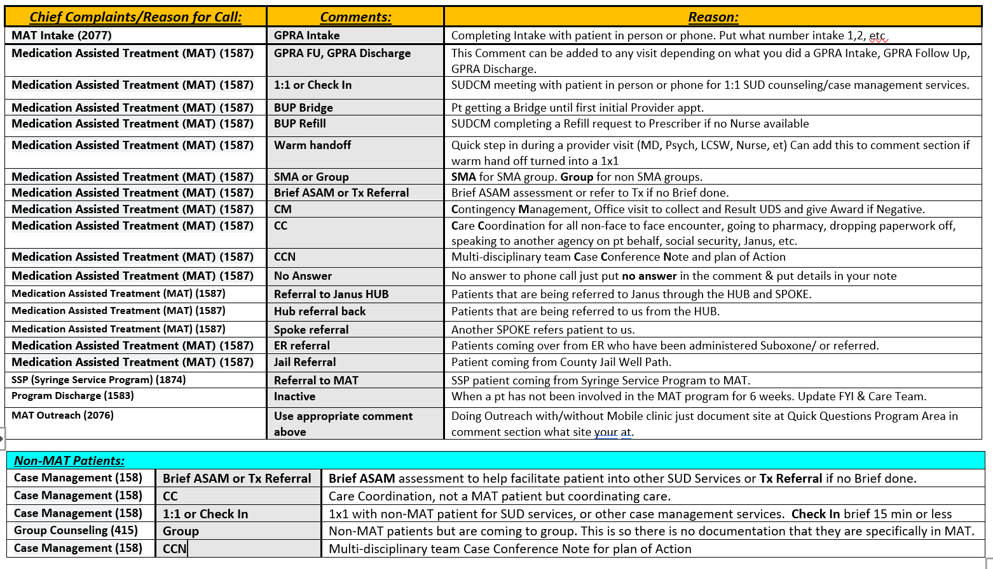

MAT Smart Phrases and Codes
Shared Drive: \\scznas06\hsa\Clinics\MAT
Narcan Training: https://www.youtube.com/watch?v=tGdUFMrCRh4

Labs & UDS Codes orders: | Watsonville | Emeline | HPHP
UDS point of care | LV5598/ LV5716 .LASTUDSMAT/.SA11UDSPOCT
HCG - Pregnancy Test | LV4971 | LT683 in house / LV5997 POCT back office | LV5987
Send out for UDS for Confirmation if patient contest or clinical reason |  | LV4969/ LBS413 (pain 8)
To check if pts is taking BUP |  | LBS361
To check for Fentanyl |  | LBS380
Breathalyzer - If requested by provider | LV5772/.sa11lastbreathalyzer
Initial MAT LABS | .SA11 MAT INITIAL
Pools for Epic
Nurse Pools: | - RN pool is 110108 – for Emeline
Emeline Team Pools: | - [110433] SA11 SCSC Yellow team  - [110310] SA11 SCSC Green team  - [110309] SA11 SCSC Purple team
MAT Pools: | - SA11 SC MAT case managers [110625] for HPHP and Emeline  - SA11 WATS MAT case managers [110626] for WHC
IBH MA Pool | - SA11 IBH MA [110329] HPHP, Emeline, WHC

Prescriber Visits .SA11MATPRESCRIBER
Nurse Visit: .SA11MATNURSEVISIT
MA Notes: .SA11MATMA
Letters: SA11 Blank / SA11 MAT PT Inactive (it’s in English and Spanish delete one)

.SA11MATSMACHECKIN= is the MAT check in sheet
.SA11MATSMACHECKIN = SMA sheet

MAT Tx Tier | Doses of Case Management/SUD counseling
Tier 1 | Weekly one on ones and/or SMA/Group
Tier 2 | Weekly one on ones and/or SMA/Group
Tier 3 | Every 2 weeks one ones and/or SMA/Group
Tier 4 | Once a month one on ones and/or SMA/Group
Tier 5 | Once a Quarter one on ones and/or SMA/Group
Tier X | No interaction / Brief Case Management if needed
Tier Y | No Interaction / Brief Case Management if needed
Tier Z | As need/ Brief Case Management if needed

Support for MAT Prescribers UCSF warm line- Ron Goldsmith: 1-855-300-3595https://pcssnow.org/medication-assisted-treatment/Verify a Patients Court Date: www.santacruzcourt.org

MAT FYI’s: | Smartphrase for FYI | Status/ INFO | Group/1:1 SUDCM/IBH
Medication Assisted Treatment | .SA11MATTierInactive | Inactive after 6 weeks
Tier 1 | .SA11MATTier1 | Induction - 2 weeks | weekly
Tier 2 | .SA11MATTier2 | Early Treatment - 12 weeks (3 months) | Weekly
Tier 3 | .SA11MATTier3 | Stabilization - 12 weeks (3 months) | Every other week
Tier 4 | .SA11MATTier4 | Maintenance - 6 months – 1 year | Once a month
Tier 5 | .SA11MATTier5 | Continual Maintenance -1 year or more | Individualized
Tier X | .SA11MATTierX | Referred to Janus HUB or at Janus Methadone Clinic
Tier Y | .SA11MATTierY | Receiving MAT services at another place
Tier Z | .SA11MATTierZ | Only getting SUD Case Management services no meds, Brief Services
Clinic | Office | MAT Staff Work Cells | Extensions
Homeless Person Health Project (HPHP)  E-Fax# 831-454-3424 | 831-454-2080 | Nurse Jasmine 831-201-2485  Angelica Torres 831-566-9347  Gabriel Tapia 831-331-6048 | X 5199  X 5197
Watsonville Health Center (WHC)  Fax # 831-763-8237 Suite C | 831-763-8400 | Alejandro Monroy 831-247-4193  Andres Galvan 831-227-9967  Rosie Saldivar 831-359-2992 | X 763-8127  X 763-8056  X 763-8253
Santa Cruz Health Center (Emeline)  Fax# 831-454-4296 Front Reg | 831-454-4100 | Jose Fernandez 831-345-9015  Marissa Torres 831-421-1033  Cindy Garibay 831-535-2259 | X 4454  X 5452  X 4553
Health Services Manager | 831-454-4460 | Danny Contreras 831-212-3498 | X 4460
IBH MA’s | IBH/MAT LINE: (831) 454-4808
HPHP | Alexis Carillo |  | X 2080 / 5198
WHC | Yvette Tavera |  | X 8426
Emeline | Shannon Shakespeare-Leon  Liz Jacobo |  | X 4064  X 4302

**Medications to use with caution when prescribing Buprenorphine**
Cyclobenzaprine, Soma, Tizanidine, Carisoprodol, Baclofen, Methocarbamol, Flexeril
Midrin- brand name for isomethaptene/dichloralphenazone/acetaminophen- migraine medication- it has been discontinued but worth mentioning (Dichloralphenazone is metabolized to chloral hydrate- a powerful sedative/hypnotic)
Fioricet and Fiorinal- (used for tension headaches) – both contain butalbital- a barbiturate
- These are all muscle relaxers with SIGNIFICANT abuse potential. They are considered sedative/hypnotics which have an additive effect when combined with other sedating medications such as opiates which means there is increased risk of respiratory depression and death.
Do not use at all:
Tramadol- it lowers the seizure threshold when combined with buprenorphine which means increased risk of seizures.
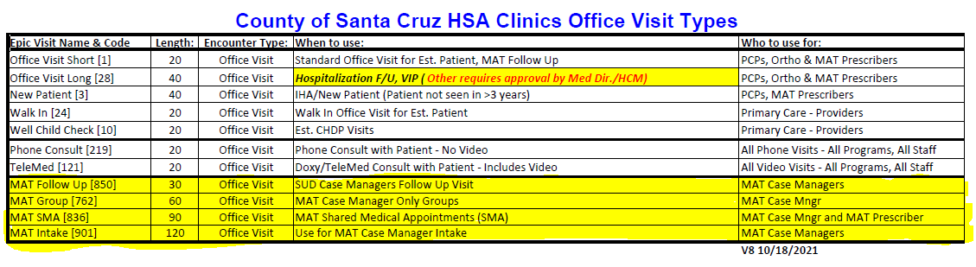
Video on injectable Narcan (English)
https://www.youtube.com/watch?v=wsN0ijLnK2k
(Spanish)https://www.youtube.com/watch?v=ERgUGnMlpcQ

Video on nasal Narcan (English-Santa Cruz SSP site)
http://santacruzhealth.org/HSAHome/HSADivisions/PublicHealth/SyringeServicesProgram.aspx
(Spanish) https://doseofreality.com/resources/naloxone-training-video-spanish/

VI-SPDAT Training
https://www.orgcode.com/
https://www.youtube.com/watch?v=z_pHYPTw0Zw

When working off a Laptop to select smartsets in your Smartphrase in your note click Fn and F2.

Alliance: Switch PCP 1-800-700-3874/ 1-831-430-5505
To switch patient PCP to the County Clinics. Call this number say patient wants to switch, they will ask to speak to patient. Patient will speak to them and give them their current information address, phone number, etc. Make sure they make them an ADMIN member until they are assigned to us on the 1st and get the Confirmation# to document in epic. Patient needs to say they will be seen today. Phone call shouldn’t take more than 5 minutes.

After Hours Phone #: 454-5146/763-8227 Someone can give patient a bridge to get them through the weekend or holiday, till the MAT team can see them.

ER Bridge: If it is an emergency and nobody can be reached after hours, holidays, weekends patient can access care at local ER. ER will only dispense 1 day at a time for a total of 3 days. Should be enough to get patient an appointment at our clinics. ER will notify Danny or call new MAT/IBH Line 831-454-4808.

Dominican ED- 1. NASH Social Worker 831-212-4255 2. ED Social Worker 831-462-7306 3. Charge Nurse 831-462-7730
Watsonville Community Hospital ED- Ashlee Deherrera 408-840-6988

Structure of SMA & Medical Groups:
- Lead a meditation (1-3 min)
- Check in: (5-10 min)
- Review Last week’s Topic Briefly (2 min)
- Pass out hand out and go over curriculum (30 min)
- Check out: (5-10 min)

