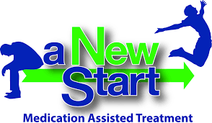Program Requirements: Attend groups and individual meetings determined by tier and treatment team.
Tx Tiers | Prescription | Group/IBH
Tier 1 Induction (2 weeks) | Weekly | Weekly
Tier 2  Early  Treatment (12 weeks) | Weekly | Weekly
Tier 3  Stabilization (12 weeks) | Every other week | Every other week
Tier 4  Maintenance (6 months to 1 year) | Once a month | Once a month
Tier 5  Maintenance | Once a month | Once a month

You can graduate from each tier by providing negative urine drug screens and adhering to your group and/or scheduled appointments with IBH.

Relapse: If during treatment there is a relapse, you’ll return to Tier 2 level of care and more support will be provided.

Appointments: It is very important that appointments are not missed. If you must miss, please call to reschedule ahead of time.

Drug test: Patients will be drug tested at every visit.
Have more questions?

Contact Us

Homeless Person Health Project (HPHP)
115 Coral St. Santa Cruz CA, 95060
831-454-2080
Nurse Jasmine 831-201-2485
Angelica Torres* 831-566-9347

Watsonville Health Center (WHC) 1430 Freedom Blvd, Ste. C Watsonville, CA 95076

831-763-8400
Alejandro Monroy* 831-247-4193
Andres Galvan* 831-227-9967

Santa Cruz Health Center (Emeline)
1080 Emeline Ave, Building D Santa Cruz, CA 95060
831-454-4100

Greg Goldfield | 831-331-6048
Marissa Torres* | 831-421-1033
Adam Echols | 831-400-6669
Health Services Manager Danny Contreras 831-212-3498

*Habla Espanol

COUNTY OF SANTA CRUZ
Health Services Agency
Medication Assisted Treatment

COUNTY OF SANTA CRUZ

THANK YOU FOR INQUIRING ABOUT THE SANTA CRUZ COUNTY HEALTH SERVICES AGENCY MEDICATION ASSISTED TREATMENT (MAT) PROGRAM. THIS PAMPHLET WILL GIVE YOU GUIDELINES ABOUT WHAT TO EXPECT FROM OUR PROGRAM.

Who we are?
We are a team of healthcare providers,
addiction counselors, case managers, registered nurses, medical assistants, and behavioral health specialists dedicated to supporting our patients in their recovery from opiate addiction through an integrated, patient-centered approach.

Medication Assisted Treatment (MAT)
Day | Time | Location
Monday  MAT group | 2-3 pm | WHC (atrium)  Building A
Monday  SMA | 9:30 -11 am | Emeline  (room #109)
Tuesday  SMA | 10 – 11:30 am | WHC (atrium)  Building A
Tuesday  SMA | 1:30 -3 pm | HPHP  (HM community room)
Tuesday  MAT group | 3:30-5 pm | Emeline  (room#109)
Wednesday  MAT group | 4-5 pm | Emeline  (room#109)
Wednesday  MAT group | 5-6 pm | WHC (atrium)  Building A
Thursday  MAT Spanish | 5-6 pm | WHC (atrium)  Building A
Friday  MAT group | 11-12 pm | HPHP  (HM community room)
MAT is a whole person approach that provides effective treatment for opioid use condition. MAT combines FDA-approved medications to treat opioid use disorder along with counseling and behavioral therapy in the comfort and privacy of a medical office.

Some people are on this medication for short periods of time while others remain on it for years or even lifelong to prevent relapse. Buprenorphine suppresses cravings and allows people to get back to their lives.
We work with each person to develop an individualized plan to provide support through induction, stabilization, maintenance, and even relapse.

Is this the right treatment for me?
The intake appointment will help determine if
you’re appropriate for this program.

How do I get started?
Step 1: Set up an intake appointment with one of our counselors. We will go over program requirements with you at this meeting. You will be asked to submit specimens for drug screen/blood tests.
Step: 2: You will be required to start attending MAT group weekly. An appointment with a medical provider will be scheduled after you have completed group and lab test results are reviewed.

Health & Recovery Groups

THE OPIOID RECEPTOR:
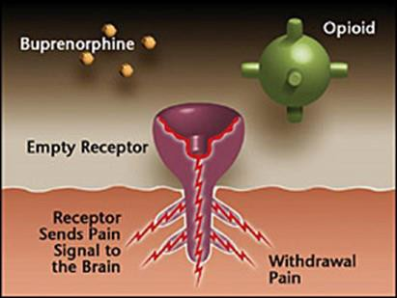

Buprenorphine is an opioid partial agonist that attaches to the opioid receptors and binds to them partially, enough to suppress withdrawal and cravings, but not enough to cause extreme euphoria or high. It also pushes off other opioids from the receptor, which is why if you are not in withdrawal and take it, it can make you sick.

Opioid agonists are drugs that bind to and cause the opioid effect. These include heroin, oxycodone, Norco, Vicodin, and methadone.

Opioid antagonists are drugs that block and reverse the effects of opioids. Narcan is an antagonist that is used to reverse heroin overdoses. Narcan can save lives. Your primary care provider will prescribe you Narcan. We will discuss with you how to use and administer Narcan.

