­

Date: ________________________________

Name: ________________________________

Following a healthy lifestyle will help you manage your weight and improve your daily life

Your TCC Care Team is here to help you achieve your everyday health goals.

**HEALTHY LIFESTYLES**

**GOAL CONTRACT**

|  |  |
| --- | --- |
| What goal will you choose? |  |
| When will you do it? |  |
| Level of Confidence  (that you will meet your goal) | 1 2 3 4 5 6 7 8 9 10  Not Sure Very Sure |

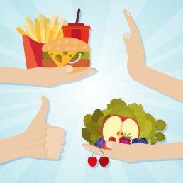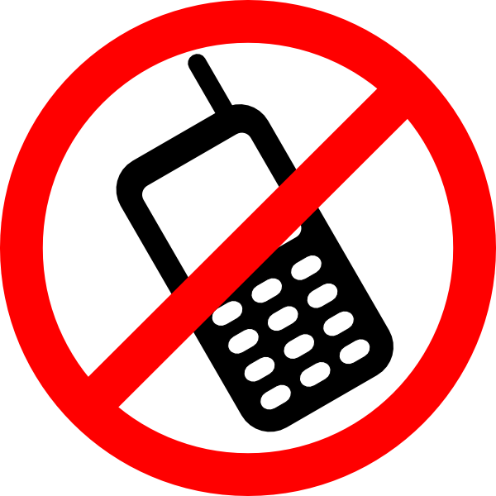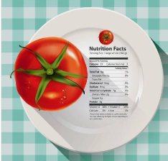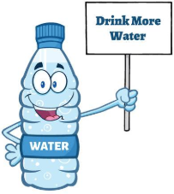

www.thechildrensclinic.org

________________________________

Educator or Provider’s Signature

________________________________

Patient or Parent Signature

Eat less junk food

Make the healthy choice the easy choice

Cut down on screen time

Try new and different way to stay active

Exercise regularly

Eat smaller portions

Eat more fruits and vegetables

Read nutrition labels

Eat a healthy breakfast

Eat less fast food

Drink water instead of soda or juice

Talk to your provider about any problems you are having