Connected Care Accelerator (CCA) Metrics Data Collection Guidance
Updated January 2021
Overview of the data we are collecting
As part of your participation in the Connected Care Accelerator (CCA) program, you have agreed to submit aggregate data on primary care visits and behavioral health visits by month, for each month starting in February 2019 through August 2021. We are collecting data on in-person visits, video visits, and telephone visits as well as the payers for these visits across the three modalities. We are also requesting data on the patients served each month across the three modalities by race, ethnicity, age, and gender. This data is essential for us to build a case for sustained reimbursement and support for virtual care in future years.
Why are we collecting these data?
The CCA evaluation team (RAND and CCHE) is planning to analyze the data clinics provide to describe trends in telehealth use and to characterize the experiences of diverse health centers in expanding telehealth during the COVID-19 pandemic. For example, we are interested in exploring which populations are being served by video vs. telephone visits and whether telehealth visits are helping to offset reduced demand for in-person care. The data will be analyzed and presented in peer-reviewed publications and in a final report. This analysis will be an important contribution to the literature on the impact of COVID-19 and recent healthcare delivery changes on safety net populations and one of the first analyses that will be able to explore impacts by race/ethnicity and by payer. Information published in peer-reviewed publications will be disseminated broadly to ensure that it reaches healthcare practitioners and policy makers and can inform the response to COVID-19.
Data collection timeline and procedures
You will be asked to submit data at three time points from September 2020-September 2021. The first data submission will be due in September 2020 and will cover the period of February 2019-August 2020 (18 months). The second data submission will be due in March 2021 and will cover the period of September 2020-February 2021 (6 months). The third and final data submission will be due September 2021 and will cover the period of March 2021-August 2021 (6 months). For each of these data submissions, you will receive a data collection spreadsheet tool that you will be asked to complete and email back to the evaluation team. The first data submission will be slightly more time-consuming than the subsequent two submissions. This is because in the first submission, we are asking for a year of pre-pandemic data as well as baseline information on payer mix, volume, and patient population in 2019.
We expect that you may need to involve several staff members at your health center to track down the information you need to complete the spreadsheet. It is fine to circulate the spreadsheet among staff at your organization. However, please designate one person who is responsible for sending one final (and approved) version to the evaluation team.
When you are ready to submit the final data collection spreadsheet, please email it to Lori Uscher-Pines (luscherp@rand.org) (Infrastructure and Spread track) or Natasha Arora (Natasha.B.Arora@kp.org) (Learning Collaborative track). We will confirm receipt and may get in touch with you to ask follow-up questions or to request updates in case anything is incomplete or unclear.
Snapshot of data collection spreadsheet
In the spreadsheet you will be completing, the metrics will be listed as rows and calendar months as columns. A screenshot of the spreadsheet is included below. We ask that you complete as much of the spreadsheet as you can and that you not change or manipulate definitions or categories. If you have challenges completing any part of the spreadsheet or have important contextual information that you would like to relay to the evaluation team, please include that information in the cells labeled “Comments.”
Spreadsheet Screenshot
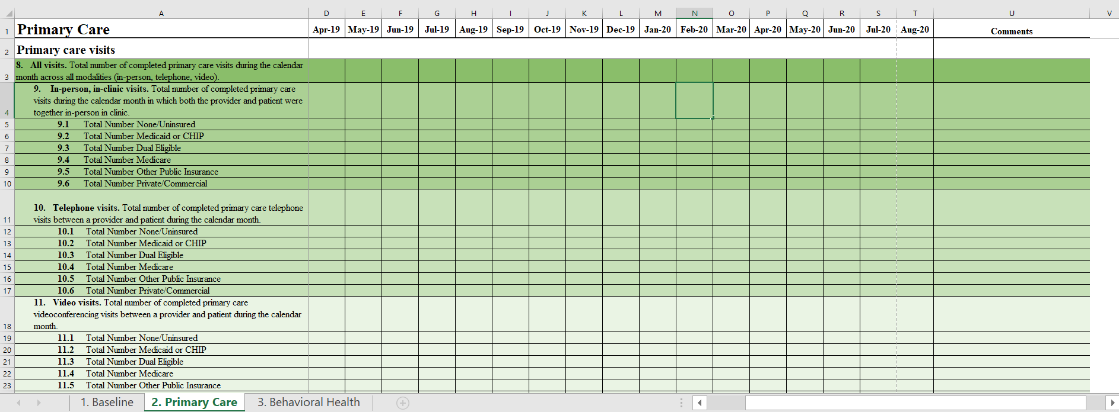
Definitions
When you are completing the data collection spreadsheet, we ask that you apply the following definitions:
Primary care visits. Primary care visits are those delivered by primary care providers including internal medicine physicians, family physicians, general practitioners, pediatricians, and non-specialty PAs and NPs in outpatient settings. Primary care does not include behavioral health visits delivered by specialty behavioral health providers including psychiatrists, psychiatric/mental health NPs, psychologists, social workers, etc.; however, a visit with a primary care provider for a behavioral health issue (including substance use disorders) would be included. A visit with a primary care provider for prenatal care would also be included. Primary care visits do not include visits with nurses, obstetricians, gynecologists, midwives, laboratory personnel, dentists, dental hygienists, ophthalmologists, optometrists, case managers, outreach workers, or community health workers.
Behavioral health visits/visits with specialty behavioral health providers. Behavioral health visits are those delivered by specialty behavioral health providers who are credentialled by the clinic. Eligible providers include psychiatrists, social workers, substance abuse counselors, marriage and family therapists, psychologists, psychiatric/mental health NPs and PAs, and other licensed mental health providers. As above, we would like you to report on outpatient behavioral health visits only.
Telehealth visits. Telehealth visits are defined as interactive, synchronous visits that use audio (telephone) and/or video telecommunications technology/equipment. Telehealth visits are comprised of live, two-way telephone or video visits only. (Do not count eConsults, email, patient portal messages, mobile health [mHealth], store and forward telehealth visits, remote patient monitoring, or Project Echo activities in this data collection.) To count as a visit, care must be provided by a provider credentialed by the clinic, and the visit should be conducted as an alternative to an in-person primary care, behavioral health, or non-behavioral health specialty visit.
- Telephone visits. Audio only visits. A telephone visit in this case should be used as a replacement for care that would otherwise be billed as an in-person visit. To qualify as a telephone visit, the patient and provider can be in any location (clinic, home, car) but should not be in the same room together, in-person. Calls to a nurse hotline for triage purposes or calls for refill requests are not “visits” based on our definition.
- Video visits. Visits that use videoconferencing software/platform. In a video visit, both the provider and patient should be able to see as well as hear one another. A video visit in this case, should be used as a replacement for care that would otherwise be billed as an in-person visit. To qualify as a video visit, the patient and provider can be in any location (clinic, home, car) but should not be in the same room together, in-person.
New patient. A new patient is one who in a given month has not had any prior visits at the health center for that particular service (e.g., primary care or behavioral health) in the past three years. Patients can be new behavioral health patients even if they have received primary care services at the health center in the past three years and vice versa.
Payers. We are using HRSA UDS categories for the payers:
  - None/Uninsured: Include all visits among patients without health insurance
  - Medicaid or CHIP: Include all visits covered by Medicaid or CHIP. Both managed and FFS Medi-Cal are included in this category.
  - Dual Eligible: Include all visits among patients who are dually eligible for Medicare and Medicaid
  - Medicare: Include all visits covered by Medicare. Both Medicare Advantage and Medicare FFS are included in this category.
  - Other Public Insurance: Include all visits covered by public insurance other than Medicare, Medicaid, and CHIP (e.g., VA).
  - Private/Commercial: Include all visits covered by private payers.

Q&A
How are you defining visits for this project?
A countable visit is an individual face-to-face or virtual contact between a patient and a credentialed provider. Visits are synchronous and interactive and can be delivered in-person, via video, or via telephone. We are only interested in “completed” visits that actually occurred (i.e., visits that were billable). Please do not include scheduled visits where the patient did not show or visits that were cancelled by clinic staff. In addition, we are focusing on outpatient visits across your entire organization (i.e., all sites within your organization that offer primary care and/or behavioral health services). Please exclude visits to emergency departments, inpatient visits, and visits associated with partial hospitalization programs.
How are you defining telehealth visits for this project?
Telehealth visits are defined as interactive, synchronous visits that use audio (telephone) and/or video telecommunications technology/equipment. Telehealth visits are comprised of live, two-way telephone or video visits only. (Do not count eConsults, email, patient portal messages, mobile health [mHealth], store and forward telehealth visits, remote patient monitoring, or Project Echo activities in this data collection.) To count as a visit, care must be provided by a provider credentialed by the clinic, and the visit should be conducted as an alternative to an in-person primary care, behavioral health, or non-behavioral health specialty visit.
How should we categorize unresolved telehealth visits (i.e., telephone or video visits that are immediately followed by a same day in-person visit because the clinician requested that the patient come in)?
If an unresolved telehealth visit is followed by an in-person visit that occurs on the same day, we prefer you count this once as an in-person visit rather than count it twice as a video/telephone visit and an in-person visit. If an in-person visit is followed by a telehealth visit on the same day OR if the visits occur on different days, please count them as separate visits and indicate the modality used for each. (When in doubt, use the rules you use for coding/billing.)

How should we categorize visits that are scheduled and start as video visits but become telephone visits because of technical issues, patient factors, etc.?
We prefer that you categorize the visit by the modality that was used at the time the visit concluded. In other words, if a visit started as a video visit and became a telephone visit due to technical issues, we would like you to count it once as a telephone visit. We will assume this is how you are categorizing visits unless you tell us otherwise.
If this is not how you document visits (e.g., you code the visit based on the modality in the schedule regardless of what happened during the visit), please explain that in the Comments field as well as provide a ballpark estimate of how often video visits became telephone visits in a given month.
What if we can’t differentiate between telephone and video visits?
If you can’t differentiate between telephone and video visits, please categorize all telehealth visits as whatever the most common modality was at your clinic for that month. For example, if in a given month you know that approximately 80% of the visits were by video but you can’t tell if a particular visit was telephone vs. video, categorize all the telehealth visits for that month as video (and put 0 for telephone visits). Also, please explain the assumptions that you made in the “Comments” field. We need contextual information like this to fully describe the limitations of the data.
How should we categorize group medical and behavioral health visits?
Group visits should be excluded from this data collection effort. We do not need data on in-person or telehealth-based group visits at this time. We will, however, be asking about how group visits have changed in other data collection efforts in the future.
Some of our primary care visits do not have claims attached and are not billable to any insurance. Should we assign those visits to a specific insurance category or exclude them?
Please include those visits in your submission. Categorize visits that are not billable to any insurance as “none/uninsured.”
How should we calculate age?
We prefer that you calculate age as of 1/1/2019 when reporting on 2019 data and 1/1/2020 when reporting on 2020 data.

What should we put in the Comments field?
Please explain any important context in the Comments field such as limitations of the data you are submitting, why certain data might be missing, changes in documentation that have occurred over time, etc. If you have to define or categorize anything differently from what we ask for in this guidance, please clarify that in the Comments field and explain why.
What if we can’t obtain some of these data?
If you have trouble collecting any of these data, please get in touch with the lead evaluation contact for your track. If you are in the Infrastructure and Spread track, please contact Lori Uscher-Pines (luscherp@rand.org). If you are in the Learning Collaborative track, please contact Maggie Jones (Maggie.E.Jones@kp.org). We can provide additional guidance and/or technical assistance.

Help is near!
If you have any questions about completing the data collection spreadsheet at any time in the process, please reach out to the evaluation contact for your track: Lori Uscher-Pines (luscherp@rand.org) for Infrastructure and Spread and Natasha Arora (Natasha.B.Arora@kp.org) for Learning Collaborative.

