CareMsg Quick Guide
Interface LIVE DATE 08/28/2018
How to delete an appointment:
From the Appointments link select the Reminders tab > click on the drop-down menu under Name and select External ID
Enter patient MRN, appointment date and click Apply

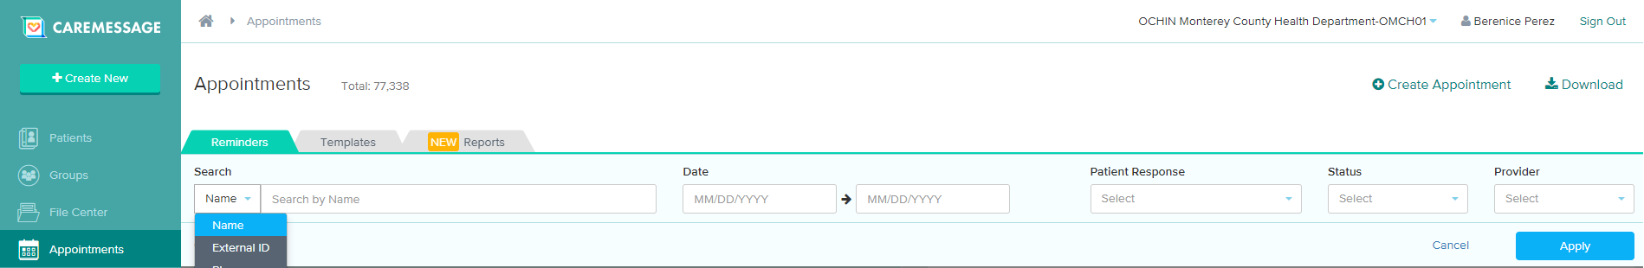

Highlight the appointment to be deleted and click Delete Appointment
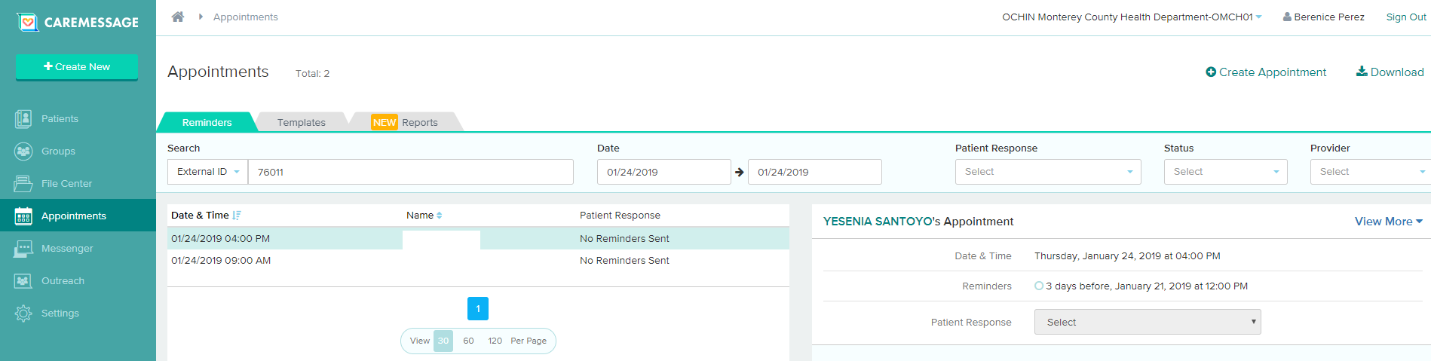

How to access the “Daily RSVP” and “Daily RSVP – Not Going” reports:
From the File Center link click on the Exported tab
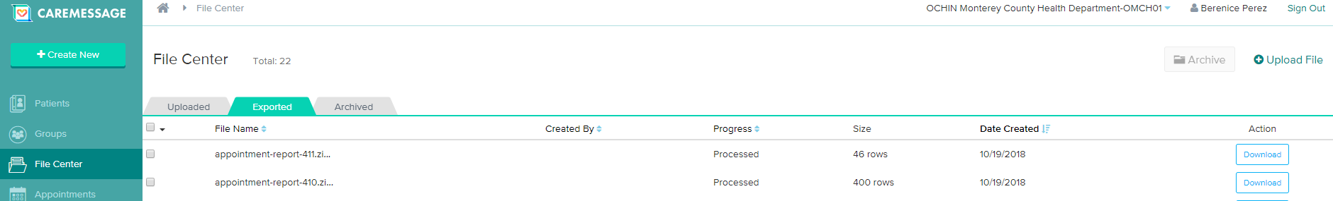
***The 410 zip file is the Daily RSVP and the 411 zip file is the Daily RSVP-Not Going***
Click on Download and open the file. Users will need to filter the files by Department/Appointment Date and remove columns that are not needed. The files will always contain appointments for today and the next day. Text reminders and the reports are generated daily.

How to view patients sharing same mobile #:
From the Appointments link select the Reminders tab > click on the drop-down menu under Name and select Phone
Enter phone number and click Apply
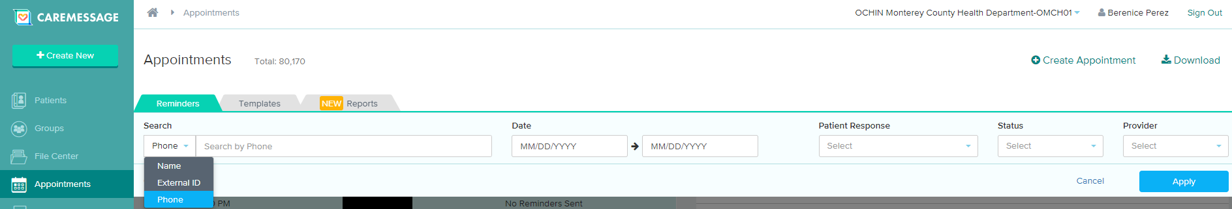

Reminders:
- Patient demographics are updated instantly.
- Patients that have confirmed their appointments via text will automatically be removed from the “Confirm Appointments Report”.
- If a clinic cancels an appointment, the patient will receive a text notifying them of this change.

