EDCHC Alcohol Withdrawal Management Summary
Patient Name:
DOB:
Date:
- CIWA score: ___
  - SAWS (Short Alcohol Withdrawal Scale) : ___
- PAWSS score: ___
- Home Caregiver: Y N
- Close to Clinic: Y N
- Review contraindications for Home Management
  - Pregnant
  - Age >65
  - Uncontrolled CHF, DM or advanced liver disease
  - History of withdrawal seizures, DTs, or multiple other withdrawal episodes
  - Impaired cognition
  - Cannot tolerate PO
  - None
- Treatment Recommendation:
  - Home Detox
  - Clinic Detox
  - Medical/Inpatient/ER Detox
- Medications: ___

- Follow Up: ___

Date
CIWA-Ar
Vitals
BAC
Meds

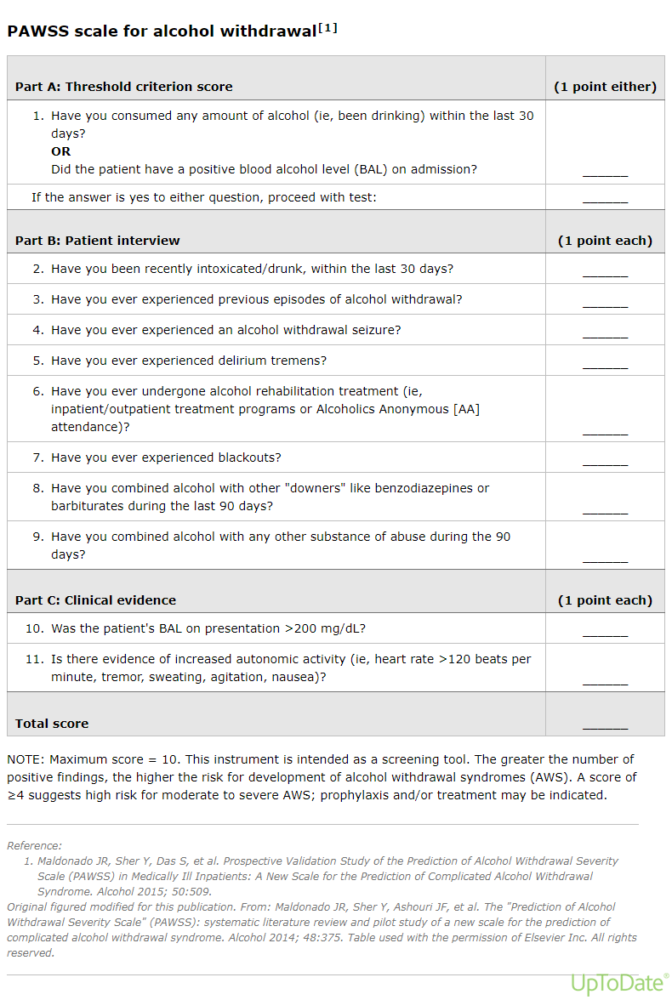

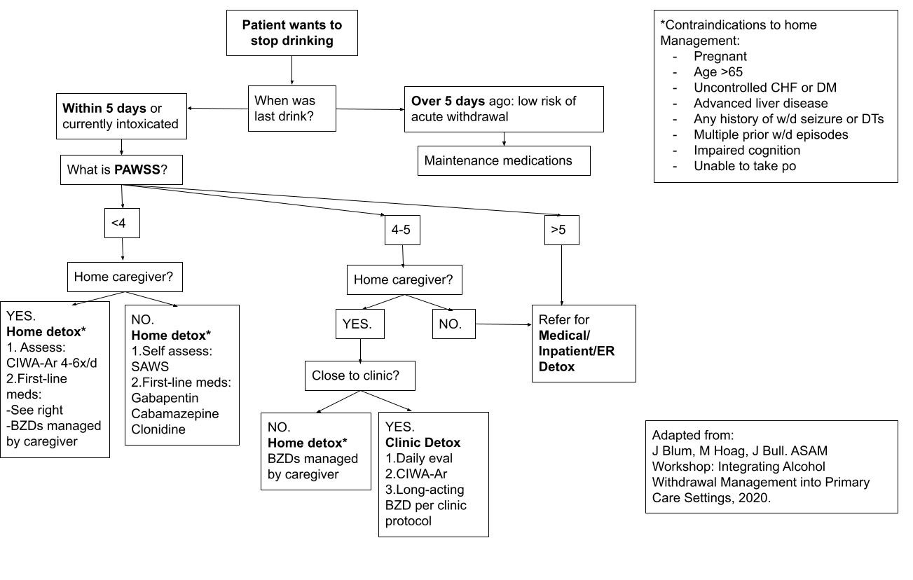
Medications Regimens for Ambulatory Withdrawal Management
Benzodiazepine – Chlordiazepoxide (Librium)  *** if signs of sleepiness or sedation switch to symptom based dosing, ie every 6 hours prn, every 8 hours prn, every 12 hours prn** | Mild Withdrawal | 25-50 mg of Librium
 | Moderate Withdrawal | 50-100 mg of Librium
 | Fixed Dosing | Day 1 25-100 mg every 6 hours (#4)  Day 2 25-100 mg every 8 hours (#3)  Day 3 25-100 mg every 12 hours (#2)  Day 4 25-100 mg at night (#1)  Day 5 25-100 mg at night (#1)  Total Doses of 25 mg x 5 days = # 11
Diazepam ( Valium)  *** if signs of sleepiness or sedation switch to symptom based dosing, ie every 6 hours prn, every 8 hours prn, every 12 hours prn** | Fixed Dosing | 5  Day 1: 5 mg every 6 hours  Day 2: 5 mg every 8 hours  Day 3: 5 mg every 12 hours  Day 4-5: 5 mg at night
Lorazepam (Ativan)  *better to use longer acting agent  *** if signs of sleepiness or sedation switch to symptom based dosing, ie every 6 hours prn, every 8 hours prn, every 12 hours prn** | Fixed Dosing | Day 1: 1 mg every 6 hours  Day 2: 1 mg every 8 hours  Day 3: 1 mg every 12 hours  Day 4-5: 1 mg at night
Carbamazepine (Tegretol)  200 mg tablet  ** doesn’t prevent Etoh withdrawal Seizures ** | Monotherapy | 600-800 mg per day, tapered to 200-400 mg over 4-9 days
 | Adjunct Therapy | 400 mg every 12 hours x 5 days (200 mg #20)
Neurontin (Gabapentin)  ** doesn’t prevent Etoh withdrawal Seizures ** | Monotherapy | Day 1: Loading dose 1200 mg x 1, then 600 mg every 6 hours  Day 2-5: 300-600 mg every 12 hours x 4 days
 | Adjunct Therapy | 400 mg every 6- 8 hours x 5 days

** For patient who require daily dosing. Should have Provider appt at beginning of week, then daily RN Case management Follow ups : Will require CIWA-Ar, Vitals, Breathalyzer and UDS. TE can then be sent to Provider working that day.

For Home management, provide patient/care giver with SAWS (Short Alcohol Withdrawal Scale).
- Mild is score < 12, Moderate to Severe is > 12.

