Key Takeaways:
WORKSHEET 5.4: Ramping Up – The Value of Small, Rapid, and Iterative Tests
- Why Test “Small”?
  - Learn from a temporary situation
  - Understand limitations of change
  - Gain buy-in from stakeholders and systems users
  - Prove/disprove predictions
  - Address unexpected outcomes EARLY
- PDSA Tips
  - Think about how to scale your test down two levels
  - The Power of 1 – Can you test your idea on the next scheduled patient, next phone call, next provider appointment?
- Tests Should be Rapid and Iterative
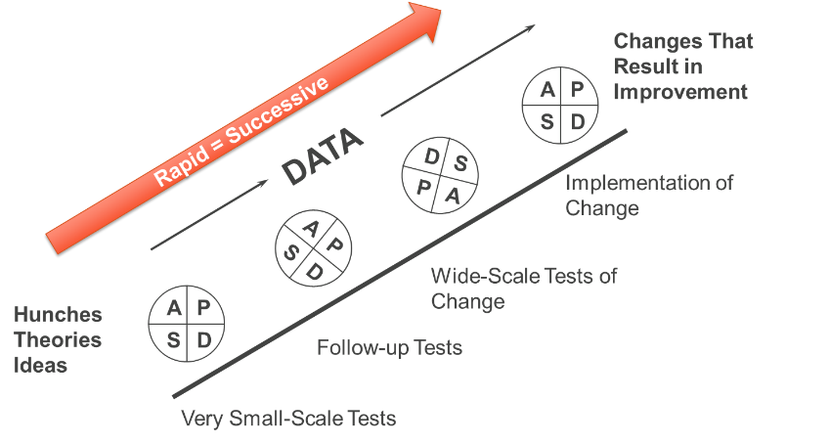

- Track iterations using a PDSA Tracker template
  - Record the details of each test to have a high degree of belief whether the test leads to an improvement
  - Plan your ramp-up to think about what future iterations might be

To Do:
- Download and print Ramping Up – The Value of Small, Rapid, and Iterative Tests
  - Record your response to the following:
    - Have you ever been mandated to implement or adopt a process/system (perhaps by a regulatory agency)? What was that experience like?

Watch the video, Ramping Up – The Value of Small, Rapid, and Iterative Tests. NOTE: To have a closer view of the documents that are being covered today, feel free to download the PDSA Tracker Template and PDSA Tracker Example. Pause the video, when instructed to do so, and complete the exercises below:

TO DOS CONTINUED ON THE NEXT PAGE

Review the Data Collection form below and perform an analysis of the data (using the questions provided):
Identified Diabetic Patient Needing Foot Exam | Was Foot Exam Completed by MA?  [If no, provide comments regarding why] | Did Foot Exam Impact Length of Scheduled Appt.? (Y/N) | If Yes, what was the difference in time | Satisfaction Rating (/) |  | Comments
 |  |  |  | Dr. Zee | MA Sally
1 | No | Yes | 15 |  |  | Filaments had not been stocked in exam room; Dr. Zee prepared while Sally found filaments and Dr. Zee performed exam to save time
2 | No | No | 0 |  |  | Pt. was experiencing chest pain, which was the focus of the appt.
3 | Yes | Yes | 5 |  |  | Pt. needed some additional instruction/ education
4 | Yes | No | 0 |  |  | MA felt well-prepared and Dr. Zee appreciated additional time that he could spend with patient

  - What might you learn from an analysis of this initial test?

  - What might your next test iteration be?

  - What might your 3rd, 4th, or 5th test iterations be?

- Head over to the Community Forum. Share your response to the following:
  - What will you build into your logistical process to ensure that those testing change ideas are able to do so rapidly and iteratively?

- If you are working with an assigned improvement coach: Use the PDSA tracker to track current PDSAs and plan to share with your coach during the next check-in meeting. Use the PDSA Tracker Template.

