DATA & RESULTS

- As number of TAPS visits increase, there is a decrease in Primary Care and Urgent Care referrals.
Note: This data is pulled from the Relay Care Reports.
- Total # of visits: 475 (as of 4/30/2014)
- 14 x-rays ordered & 32 labs ordered
Note: This data is pulled from the provider log.

- Median = 6 visits per 4 hour session (Jan – 7, Feb – 5, Mar – 4.5, Apr – 7)
- Highest = 13 visits/4 hour session
- Lowest = 1 visit/4 hour session
- Majority of TAPS visits were on Monday & Wednesday

- Highest inappropriate calls from CMHC
- Lowest inappropriate calls from CPHC & PHHC

NAL Appropriate Calls - Referral Rate: Jan 2014-April 2014
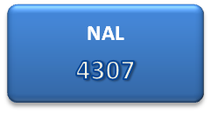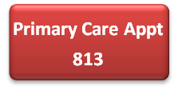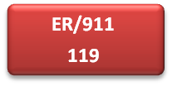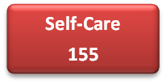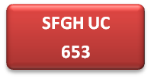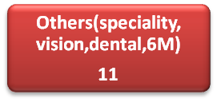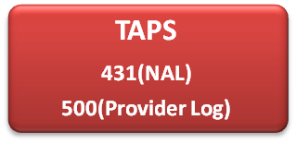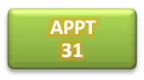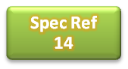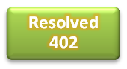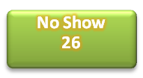

Note: This data is pulled from the Relay Care Reports
There is an inconsistency between NAL and Provider log sources of data. Provider log is more accurate and timely because it is updated by TAPS providers as they receive calls.
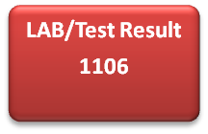
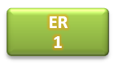
The conversion adapted when switched from 1-5 scale to 1-10 Scale is the following:
- Rate 3 equivalent to rate6
- Rate 4 equivalent to rate 8
- Rate 5 equivalent to rate 10

Primary Care Provider's Surveys

Q1. I believe that the TAPS Urgent Care telephone visit is, in general, a good method for improving patient care.
Q2. I received my patients’ assessments and treatment plans that occurred during the TAPS visits.
Q3. I feel that the TAPS provider appropriately addressed my patients’ concerns.
Q4. I found that the TAPs program was useful in helping me manage my patients’ care.
Q5. I would recommend my patients to use the TAPS program for issues that can be resolved through the phones

Q6. All providers (N=15) are in support of the Continuation of TAPS.

Metric Grid
Metric | Description | Purpose | Method/Frequency | Data Source
Patient Satisfaction Survey | Telephone survey for patients who are referred to TAPS  See below for sample survey | Clinical follow up and overall patient feedback for program | RN who referred patient to TAPS is responsible for follow-up call within a week of visit. | Survey responses
Productivity Rate | Number of visits per 4 hour session | Measure of patient demand and utilization of program | Physician Lead is to review the number of visits seen in a 4 hour session weekly. | Provider logs¹
Inappropriate Calls | Number of calls to the NAL that do NOT fall under the following:  - Acute Care  - Health Ed  - Lab results  - Self – care advice | Assess the impact of TAPS on patient referrals to Urgent Care and Primary Care Clinic appointments | A designated Health Worker will pull referral rates on a weekly basis. This information will be shared with Management Teams at the clinic. | Relay Care Report²
Provider Surveys | Survey emailed to all Primary Care Providers  See below for sample survey | Elicit feedback from PCPs and identify improvement areas | Data coordinator will be responsible to email survey on a quarterly basis | Survey  responses
Chart Audit | TAPS providers/ Physician Lead will review patient charts for appropriateness and quality of care | Ensure high quality of service and identify improvement areas | At least 10 of patient charts for new on-boarding providers will be audited. After, providers will be expected to audit another provider’s charts on a monthly basis. | Chart Audit Validation Checklist³
TNAA  (not specific to TAPS) | Number of days for the third next available appointment | Evaluate the impact of TAPS on a system level | SFHN wide measurement of patient access, collected on a weekly basis by the clinics | TNAA report
CG-CAHPS  (not specific to TAPS) | Patient survey administered for the evaluation of their experiences | Evaluate the impact of TAPS on a system level | 12-month quality improvement survey | CG-CAPHS report
¹Provider logs – Tracking sheet updated by TAPS Providers that captures MRN, date of visit, patient concern, and whether a resolution or referral was made (see attached template)
²Relay Care Report – Database that the NAL documents each telephone encounter
³Chart Audit Validation Checklist – Details for this measure is yet to be determine
Script for Patient Satisfaction Survey
Hello, my name is ________. I am calling from the San Francisco Department of Public Health for (patient's name) regarding the telephone visit that happened on (date of visit). This is a patient survey to get feedback on how we can improve our telephone services. Do you have a few minutes to answer a couple of questions about your experience? Ask questions. Thank you and have a nice day!

Patient Satisfaction Survey Questions
Did you receive the call within an hour of the time given? Yes/No
Did the provider answer all of you questions? Yes/No
Is Telephone Visit a service you would use again in the future? Yes/No
In a scale from 1-10, how do you rate your overall experience with the provider? (1 – poor, 10 – excellent)

Provider Surveys
Questions | Responses – Please select one option.
I believe that the TAPS Urgent Care telephone visit is, in general, a good method for improving patient care. | Strongly disagree □ Disagree □ Agree □ Strongly Agree □  No Opinion/Not Applicable □
I received my patients’ assessments and treatment plans that occurred during the TAPS visits. | Strongly disagree □ Disagree □ Agree □ Strongly Agree □  No Opinion/Not Applicable □
I feel that the TAPS provider appropriately addressed my patients’ concerns. | Strongly disagree □ Disagree □ Agree □ Strongly Agree □  No Opinion/Not Applicable □
I found that the TAPs program was useful in helping me manage my patients’ care. | Strongly disagree □ Disagree □ Agree □ Strongly Agree □  No Opinion/Not Applicable □
I would recommend my patients to use the TAPS program for issues that can be resolved through the phone. | Strongly disagree □ Disagree □ Agree □ Strongly Agree □  No Opinion/Not Applicable □
I support the continuation of TAPS. | Yes □ No □

Any other suggestions, comments, or concerns (please use back of survey, if more space needed):

Provider Log Template
TAPS Visit Data
Provider | Patient Name | MRN | Home Clinic | Date of Provider Call | Interpretor Used? (Yes or No) | Showed for call? (Yes or No) | Reason for Call | Resolution (ER, UC, APPT, SPEC REF, RESOLVED) | Labs (yes or no) | Radiology (yes or no) | Nurse follow-up needed? (yes or no)

