STORY OF SELF

story of self
OBJECTIVES:
By the end of this training, you will…

- Learn the basics of how stories work to convey values & emotions
- Learn criteria for an effective story of self and coach others on improving their storytelling
- Practice and get feedback on your own story of self

RELATED SESSIONS:
- Story of Us/Now

EACH OF US HAS A COMPELLING STORY TO TELL

Each of us has a story that can move others to action. As you learn this skill, you will be learning to tell a story about yourself, your community, and the work that you’re doing to motivates others to join you in creating change. In addition, you will gain practice in listening, and coaching others to tell a good story.

STORIES: A REFLECTION OF OUR VALUES AND GOALS

Stories are how we learn to make choices and construct our identities and purpose—as individuals, as communities and organizations, and as nations.
What do stories have to do with work and goals? You can’t ask others to follow you or implement a change if they don’t understand what your intentions are, and why you are called to the work you’re doing. Your story also helps outsiders to see why the work you’re doing is important and how this work can make a difference in real people’s lives.

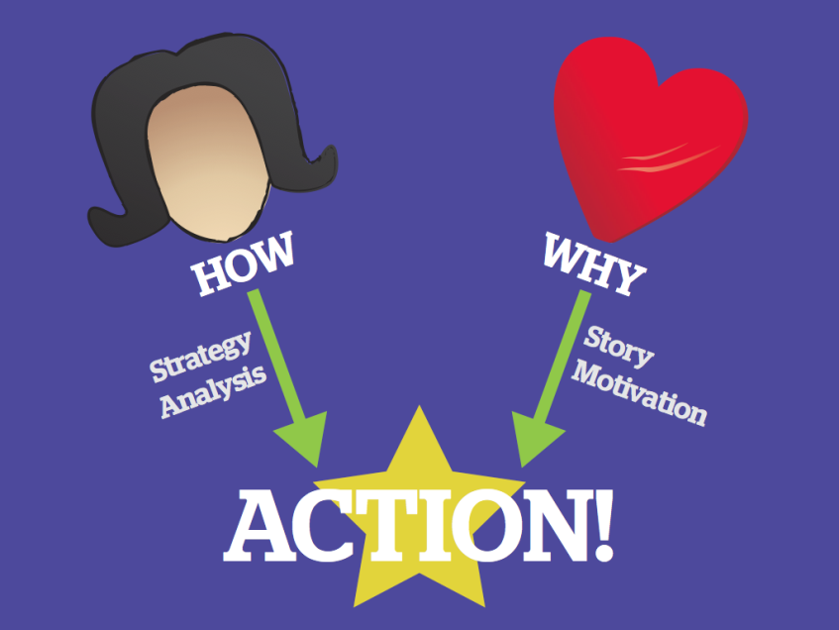
THE HEAD & THE HEART

There are two ways we understand the world: through our head (strategy &analysis) and through our heart (story & motivation). To enable others to achieve shared purpose, people who want to make changes must employ BOTH the head and the heart to mobilize others to act on behalf of shared values. In other words, they engage people in interpreting why they should change their world (their motivation) and how they can act to change it (their strategy). Stories are the “why”—the art of translating values into action through stories.

VALUES INSPIRE ACTION THROUGH EMOTION

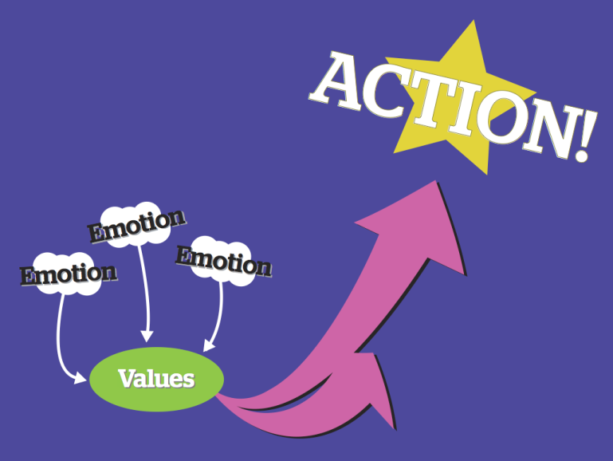
We don’t think our values; we feel our values. Often we don’t realize what we value in the world until we hear a story or witness an injustice that stirs emotions within us. Emotions inform us of what we value in ourselves, in others, and in the world, and they enable us to express the motivational content of our values to others. Because stories allow us to express our values, they have the power to move others to action.

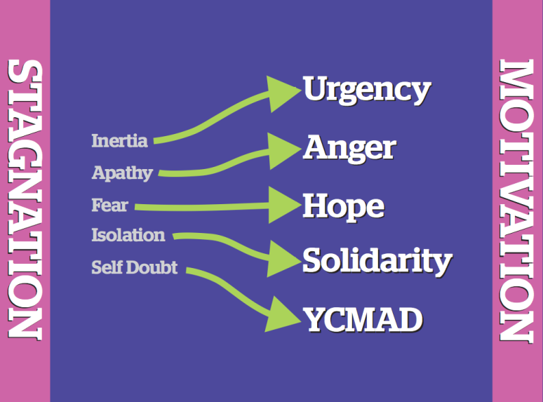
SOME EMOTIONS INHIBIT ACTION, OTHERS MOTIVATE ACTION

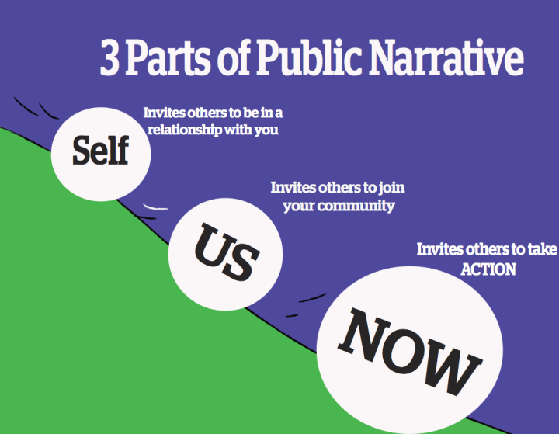
People trying to create change often encounter individuals or groups where action is inhibited by inertia, fear, self-doubt, isolation, and apathy. The job of people trying to create change is not to tell others to stop feeling this way but rather use storytelling to move people from feelings of stagnation to feelings of motivation - urgency, hope, YCMAD (you can make a difference), solidarity, and anger. The language of emotion is the language of movement—they actually share the same root word. Stories mobilize emotions of action to overcome emotions that inhibit us from action.

PUBLIC NARRATIVE COMBINES A STORY OF SELF, US AND NOW

STORY OF SELF
By telling a “story of self” you can communicate the values that move you to want change. Your “story of self” sheds light on the reality of an issue and makes a theoretical problem into a real person who experienced real emotions because of the problem. Effective stories that convey values can establish trust, empathy, and understanding. In its absence, people might guess about what the underlying motivation is – are we making this change in our clinic because it saves money for the system but makes a worse experience for patients? Or are we making this change in our clinic because someone is being unfairly treated due to the current policy? Telling your story of self can help establish firm ground for collaboration and discovering common purpose.
Every one of us has a compelling story of self to tell. We all have people in our lives (parents, grandparents, teachers, friends, colleagues) or characters we love, whose stories influence our own values. And we all have made choices in response to our own challenges that shape our life’s path— confrontations with pain, moments of hope, calls to action.

The key focus is on our choices, those moments in our lives when our values moved us to act in the face of challenge. When did you first care about being heard? Why did you feel you should act? What were the circumstances, the place, the colors, sounds? What did it look like? The power in your story of self is to reveal something of those moments that were deeply meaningful to you that motivated you to want change. Learning to tell a good story of self demands the courage of introspection, and of sharing some of what you find.

STORY OF US
By telling a “story of us” you can communicate values that can inspire others to act together by identifying with each other, not only with you.
Just as with a story of self, key choice points in the life of a community—its founding, crises it has faced, or other events that everyone remembers—are moments that express the values shared. Consider stories that members of your group have shared, especially those that held similar meaning for all of you. The key is to focus on telling a specific story about specific people at a specific time that can remind everyone – or call to everyone’s attention – values that you share. What was a positive or negative experience with healthcare that you had that others might share or understand with you? What about your story might others relate to? What about your story might invite others to share those same feelings/emotions you had? Telling a good story of us requires the courage of empathy – to consider the experience of others deeply enough to take a chance at articulating that experience.

STORY OF NOW
By telling a “story of now” you can communicate an urgent challenge we are called upon to face, the hope that we can face it and the hopeful outcome we can create together, and the choice we must make to act now.
A story of now requires telling stories that bring the urgency of the challenge alive: urgency because of a need for change that cannot be denied, urgency because of a moment of opportunity that may not return. A story of now also offers hope—not make believe hope, but real, plausible hope, often grounded in what others are already achieving, grounded in the courage of others’ actions, and in the strategic vision of what we can achieve together. At the intersection of the urgency and the promise of hope is a choice that must be made – to act, or not to act, to act in this way, or in that. Telling a good story of now requires the courage of imagination, or as Walter Brueggemann named it, a prophetic imagination, in which you call attention both to the pain of the world and also to the possibility for a better future.

STORY STRUCTURE: CHALLENGE and OUTCOME
Every human story has a plot. A plot begins with a challenge that confronts a character with an urgent need to pay attention. Out of the challenge comes an outcome, positive or negative. The outcome can teach a moral.
A good story allows the listener to empathetically identify with the character and “feel” the moral. We hear “about” someone’s courage; we are also inspired by it.
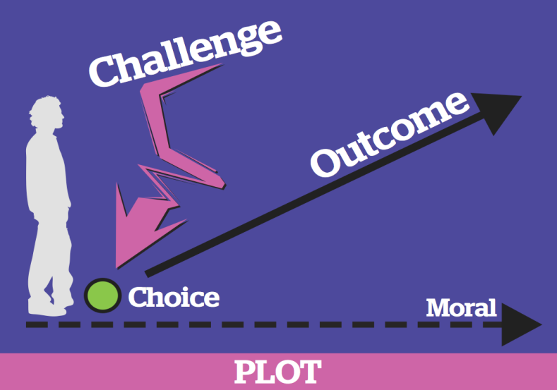
The story of the character and his or her choices, or lack of choices in the situation, encourages listeners to think about their own values and challenges, and inspires them to think about how they can make changes to the outcome with their own choices to pursue change.

Incorporating Challenge and Outcome in Your Own Story

There are some key questions you need to answer as you consider telling your story.

Challenge: Why did you feel it was a challenge? What was so challenging about it? How did it feel? Why was it your challenge?

Choice: Did you have any choices in the situation? Did you have control over the situation or outcome? If you had a choice in the situation, why did you make the choice you did?

Outcome: How did the outcome feel? Why did it feel that way? What did it teach you? What do you want to teach us? How do you want us to feel?

A word about challenge. Sometimes people see the word challenge and think it means describing the worst misfortunes of our lives. Sometimes those are the moments that most shaped us. But keep in mind that a struggle might also be one of your own choosing – a high mountain you decided to climb as much as a valley you managed to climb out of. Many things may have been a challenge to you and can be the source of a good story to inspire others.

A word about positive stories. Not all stories have to be about a negative experience to convey values. If you have a positive story, you can still use the guiding questions above for the “outcome.” This conveys to listeners the importance of having positive stories and outcomes and highlights what components of your story are needed for other people to have positive experiences too.

VIDEO REVIEW
James Croft

While you watch the video of James Croft, think about the elements of SELF – US – NOW that you hear in his story.

SELF | US | NOW
- What are his experiences and values that call him to the stage?  - What choice points does he include to show, rather than tell us his values? | - Who is the “us” that the speaker identifies?  - What are the common values that he appeals to? How?  - What challenges and hopes does this “us” or community share? | - What challenge to those values does he identify?  - How does he make that challenge real?  - What gives us hope that we can do something?  - What is the first step that each person can take to be part of the solution?

- What was Crofts purpose in telling these stories? What was he moving people to do?

- What values did his story convey?

- What details or images in particular reflected those values?

- What were the challenges, choices and outcomes in each part of his story? What moral do the outcomes teach?

TEAM BREAKOUT SESSION
GROUP PRACTICE WORK

GOALS
- Practice telling your Story of Self and get constructive feedback
- Learn to draw out and coach the stories of others

AGENDA
Total time: 65 min
 | Gather in your team. Choose a timekeeper. Articulate group agreements for how you’ll work together as during this training. | 5 min.
 | Take some time as individuals to silently develop your “Story of Self.”  Use the worksheet that follows. | 10 min.
 | Choose a partner  Practice telling your story of self.  -3-4 minutes each to tell your story  - Focus on the values you want to convey—what specific experiences shaped those values in your life?  - Be specific and give lots of detail  Use the worksheet “ Coaching Tips: Story of Self” to help guide your feedback.  - 4 minutes each for feedback:  - What values did the storyteller convey? How specifically?  - What is the Challenge and Outcome in each story? Did the person make a choice in the story or were there no choices available?  - Were there sections of the story that had especially good details or images (sights, sounds, smells, or emotions of the moment)? How did those details make you feel?  - What could the storyteller do to more effectively convey why they are motivated to pursue change? | 25 min
 | As a team go around the group and tell your story one by one  For each person:  -3-4 minutes to tell their story  -4 minutes to offer feedback from the group  *Make sure your timekeeper cuts you off. This encourages focus and makes sure everyone has a chance to tell their story. Remember, the purpose here isn’t to tell a perfect story, it’s to practice narrative as part of the work of leadership. | 25 min

WORKSHEET
DEVELOPING YOUR STORY OF SELF

Before you decide what part of your story to tell, think about these questions:

  - What change do I want to see happen? What is a problem or opportunity for improvement that I see? Of if you have positive story you want to share about how a clinic or healthcare experience inspired you, what happened well in your story? Why do you have positive feelings associated with this experience?
  - What values move me to take action and might also inspire others to similar action?
  - What stories can I tell from my own life about specific people or events that would show (rather than tell) those values and why they matter?

What are the experiences in your life that have shaped the values that call you to represent other patients on a Patient Advisory Board?

FAMILY & CHILDHOOD | LIFE CHOICES | CLINIC EXPERIENCES
Parents/Family  Growing Up  Your Community  Role Models  School | School  Career  Partner/Family  Hobbies/Interests/Talents  Finding Passion  Overcoming Challenge | Best/worst experience in clinic  An experience that inspired you  An experience that frustrated you

Think about the challenge and outcome in your story. The outcome might be what you learned, in addition to what happened. In between the challenge and outcome, was there a choice? Did you have a choice in the matter that influenced the outcome? Or was there no choice involved?

Try drawing pictures here instead of words. Powerful stories leave your listeners with images in their minds that shape their understanding of you.

CHALLENGE | CHOICE | OUTCOME

COACHING TIPS:
STORY OF SELF

Remember to balance both positive and constructive critical feedback. The purpose of coaching is to listen to the way stories are told and think of ways that the storytelling could be improved.

DON’T simply offer vague “feel good” comments. (“That was a really great story!”)
DO coach each other on the following points:

- THE CHALLENGE: What were the specific challenges the storyteller faced? Did the storyteller paint a vivid picture of those challenges?
“When you described ________, I got a clear picture of the challenge.”
“I understood the challenge to be ________. Is that what you intended?”

- THE CHOICE: Was there a choice involved? How did the choice make you feel? (Hopeful? Angry?) If there was NOT a choice involved, how did that make you feel?
“To me, the choice you made was ____, and it made me feel ____.”
“It seemed you did not have a choice and it made me feel ____.”

- THE OUTCOME: What was the specific outcome? How did that outcome make you feel as the listener? Did the outcome teach anything or make you want to act?
“I understood the outcome was _______, and it made me feel _______. But how does it relate to your work now?”

- THE VALUES: Could you identify what this person’s values are and where they came from? How? How did the story make you feel?
“Your story made me feel ________ because _________.”
“It’s clear from your story that you value _______; but it could be even clearer if you told a story about where that value comes from.”

- DETAILS: Were there sections of the story that had especially good details or images (e.g. sights, sounds, smells, or emotions of the moment)?
“The image of ________ really helped me identify with what you were feeling.”
“Try telling more details about _______ so we can imagine what you were experiencing.”
Record Feedback/Comments from Your Team Members Here:

Coaching Your Team's “Story of Self” As you hear each other's stories, keeping track of the details of each person’s story will help you to provide feedback and remember details about people on your team later. Use the grid below to track your team's stories in words or images.

NAME | VALUES | CHALLENGE | CHOICE? | OUTCOME

ADDITIONAL RESOURCES:

Videos:
- Barack Obama, Keynote Address, “The Audacity of Hope”, Democratic National Convention, July 27, 2004, Boston, Massachusetts (first 7 minutes).
- NOI Video resource center: Story of Self

Readings:
- Jerome Bruner, “Two Modes of Thought”, Chapter 2 in Actual Minds, Possible Worlds (Cambridge: Harvard University Press, 1986), p.11 – 25.
- Martha Nussbaum, “Emotions and Judgments of Value”, Chapter 1 in Upheavals of Thought: The Intelligence of Emotions, (New York: Cambridge University Press, 2001), (pp. 19-33).
- George Marcus, The Sentimental Citizen: Emotion in Democratic Politics, (University Park: Penn State University Press, 2002), Chapter 4, “Becoming Reacquainted with Emotion” (pp.49-78)
- Malcolm Gladwell, “Small Change: why the revolution will not be tweeted”, in The New Yorker, October 4, 2010. (http://www.newyorker.com/reporting/2010/10/04/101004fa_fact_gladwell)
- Ben Brandzel, “What Malcolm Gladwell Missed About Online Organizing and Creating Big Change”, in The Nation, November 15, 2010. (http://www.thenation.com/article/156447/what-malcolm-gladwell-missed-about-online-organizing-and-creating-big-change)

